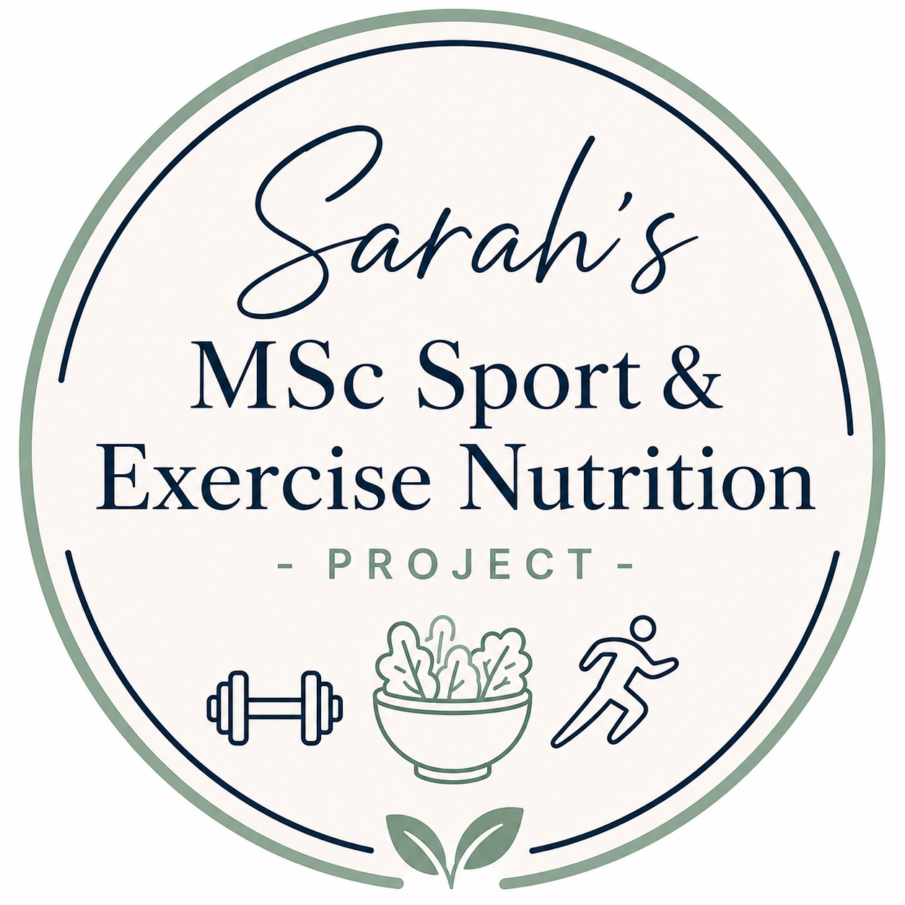
3-Day Food Diary

Guidance Notes

Please complete this food diary as accurately and honestly as possible during your selected recording week.
Please record all meals, snacks, drinks, supplements, sauces, oils, and protein-based foods consumed throughout the day.
Please include two weekdays and one weekend day.
Whilst weighing or tracking food can be helpful where convenient, there is no requirement to do this for the study. Please use the portion guides and examples provided to help estimate your usual food intake as accurately as possible.
Examples of portion sizes may include cups, tablespoons, slices, grams, packets, household measures, or weighed amounts if known.
Please try to complete all sections during the same selected recording week to help provide a representative overview of your usual dietary intake and physical activity habits.
You do not need to print the example pages or portion guide unless you would personally find them helpful. Only the food diary recording pages need to be completed and returned.
Once completed, please return this document either by email to SH2310@live.mdx.ac.uk or by leaving a printed copy at Harris Mind & Body reception for Sarah to collect.

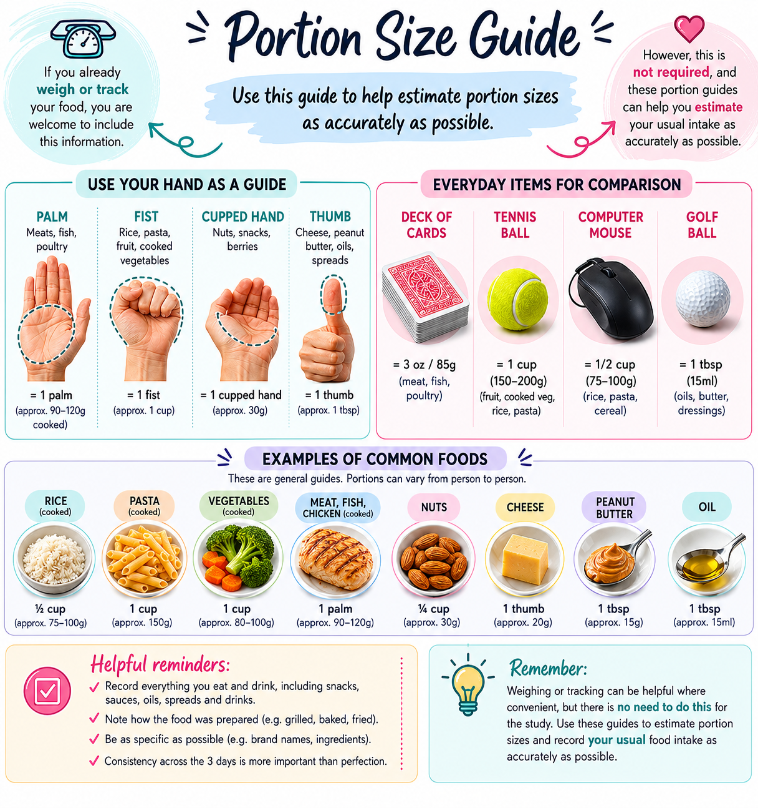

Example Food Diary Entry

This example is provided to help guide the level of detail expected when completing your own food diary. Please record your own usual food and drink intake as honestly and accurately as possible.

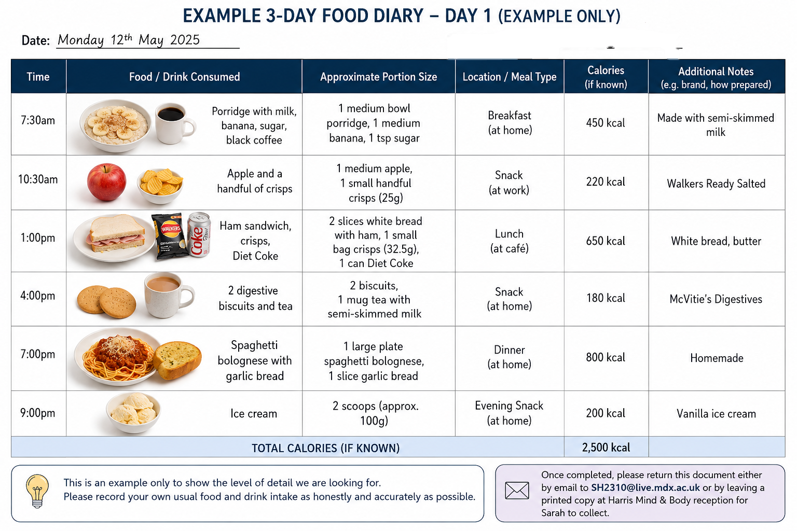

Day 1 – Weekday
Participant ID: ____________________________________
Date: ____________________________________
Time | Food / Drink Consumed | Approximate Portion Size | Location /  Meal Type | Calories  (optional) | Additional Notes

Day 2 – Weekday
Participant ID: ____________________________________
Date: ____________________________________
Time | Food / Drink Consumed | Approximate Portion Size | Location / Meal Type | Calories  (optional) | Additional Notes

Day 3 – Weekend
Participant ID: ____________________________________
Date: ____________________________________
Time | Food / Drink Consumed | Approximate Portion Size | Location / Meal Type | Calories  (optional) | Additional Notes
Continuation sheet if needed…
Participant ID: ____________________________________
Date: ____________________________________
Time | Food / Drink Consumed | Approximate Portion Size | Location / Meal Type | Calories  (optional) | Additional Notes

